Snakes in Snakewood

Snakes in Snakewood have colored rings around the tail that follow a changing pattern. As snakes grow older, the pattern extends in a systematic way.

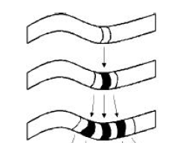 | - It starts with a white ring.  - Then a black ring develops in the middle of the white ring.  - In the next stage, the same thing happens with each white ring, but the black rings stays the same.
The process continues in the same way as the snake grows older.

Questions:
- You’ve seen the first three stages in the ring pattern. What do the fourth and fifth stages look like?
- What is the relationship between the numbers of white and black rings in each string?
- A snake has 128 white rings. How many rings does the snake have in total?
- Another snake has 255 black rings. How many total rings does this snake have?
- Is it possible for this kind of snake to have 499 rings? Why or why not?
- How can you find the number of white rings a snake would have at any stage? How can you find the number of black rings at any stage?

